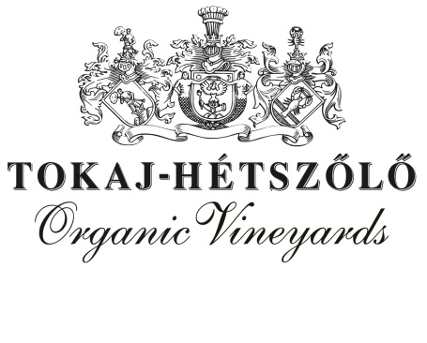

**SPARKLING FURMINT – BRUT – MÉTHODE TRADITIONELLE 2021**

**For this sparkling wine we used Furmint grapes from the Tokaj-Hétszőlő Vineyards which were established in 1502 by uniting the 7 best parcels of the Tokaj-Mountain. Before the disgorgement, it was aged in bottles for 15 months. It is an elegant, complex and vibrant sparkling wine. Cheers!**

**“We do believe that with organic approach we can protect the vitality of the vines and so have better quality now and in the future. In order to be able to communicate this philosophy we only use our own grapes to create the Hétszőlő wines.” (Gergely Makai, technical director)**

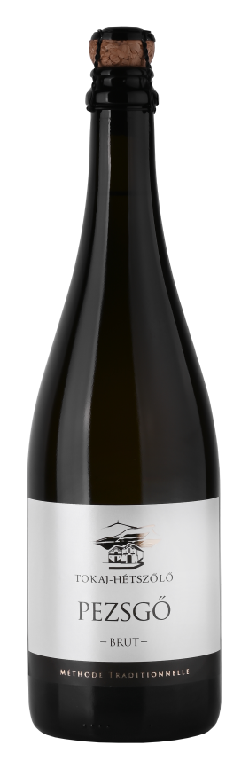

**Grape variety** Furmint 100%

**Vineyard** Nagyszőlő single vineyard, south faced

**Soil**  Thick loess soil with more complex volcanic subsoil

**Yield** 35-40 hl/hectare

**Age of vines** 25 year-old vines

**Vine density** 5500-6000 vines / hectare

**Wine making/aging** entire bunch of grapes pressing, fermentation in

stainless steel, base wine in stainless steel, then

bottle aging on lees for 24 months

**Aging potential**  5+ years

**Organic/Vegan?** Made from our own organic grapes/vegan but with

no certification

**Vintage**

2021 was a generally good vintage in Tokaj. The harvest started in the middle of

September and a lower rainfall contributed to low juice yields and high

concentration of both sugar and acidity levels in the grapes. All categories, dry,

late harvest and aszú wines ended up having a high quality.

**Analytics** alcohol : 11,5 % vol.

acidity: 9,5 g/l

sugar: 11,3 g/l (residual sugar)

**Tasting notes**

Fruity notes, lemon, apple, pear, with a good minerality and brioche aromas. Full body, elegant bubbles. It is complex and refreshing thanks to the nice acidity from Furmint grapes.

**Food recommendation**

A real pleasure to drink it on its own but would work well with seafood, fish, with green, fresh salad only olive oil on it or with lighter white pasta dishes.

**Temperature for consumption** 8-10 C°

Tokaj-Hétszőlő Zrt.

3910 Tokaj, Bajcsy Zs. utca 19-21., Hungary

tokaj@hetszolo.hu, tel.: +36-47-352-009, fax: +36-47-352-141

www.tokajhetszolo.com